**Testing Attendance Scan**

Step 1: The student log in into system.

Step 2: Student Generates the QR Code for the Class They Are Attending.

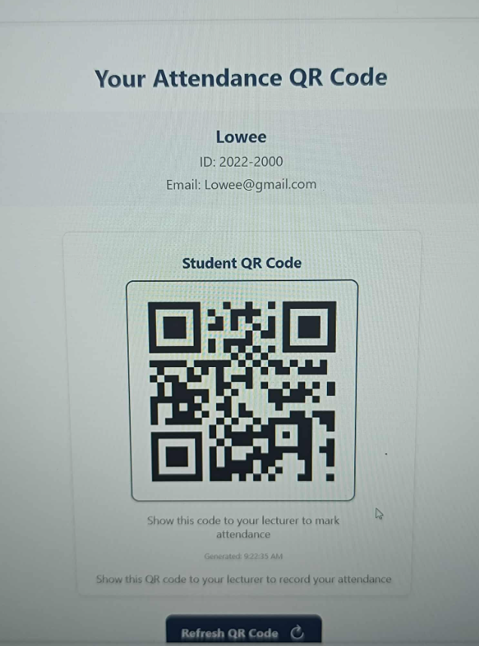

Step 3: The lecturer log in into system.

Step 4: Lecturer Scans the QR Code Presented by the Student to Record Attendance.

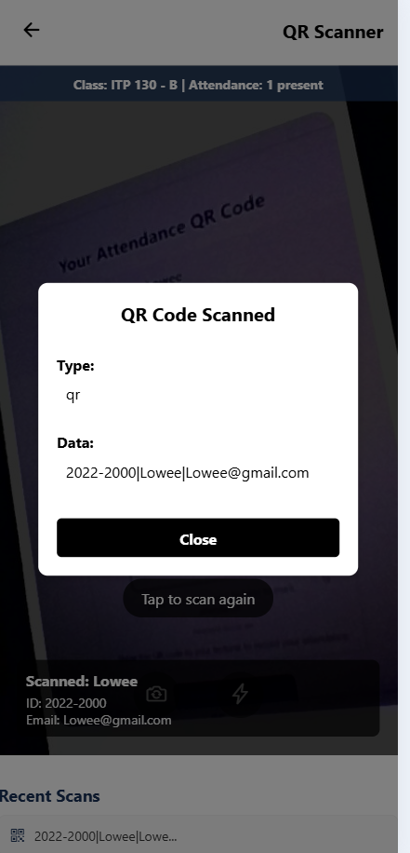

Step 5: Tester Open workbench view on to the attendance

